|  |
| --- |
|  |
| CURRENT AFFAIRS VR |
|  |
| GAME DESIGN DOCUMENT |

**LBS VHCI**

October 1, 2020

Authored by: Ryan

CURRENT AFFAIRS VR

GAME DESIGN DOCUMENT

**AIM**

This project is aimed at helping Nigerian kids/youngsters know a bit more about their country. It also aides their facial cognitive memory (ability to recognize faces). The faces of the persons in question are displayed and it’s left for the player to be able to recognize and select the appropriate faces as answers. It also aims at improving what I call “In-focus”. What this means is that, it could improve the player’s ability to focus on task at hand.

**OBJECTIVE**

The player is to choose the appropriate face that answers the question and hang on the green frame on the wall. Time is given for each question. Depending on how fast the player could answer each question, a score is given. Getting a high score by the end of the whole level, a secret level is unlocked for the player. Getting a lower score reloads the entire scene and the player would’ve to restart the game to get a high score. With respect to the timings, challenges for the player would include hiding the answer so the player could look for it to answer and get a high score before the time for the questions runs out. Another of a challenge for the player are distractions that could end up occupying the entire time of the player if he/she isn’t concentrating. This game also poses to create an awareness of the happenings in present-day Nigeria. The whole concept of the game has a poetic meaning to it, every detail, word and model used.

**HOW TO PLAY**

Carry the appropriate facial-answer of the question and hang on the green frame on the wall while trying to beat the time and get a high score while doing so.

**LEVELS**

It consists of just 4 questions which are in its own respect, levels. Each having its own difficulty from “too easy” to “hard”.

There is a bonus level that is unlocked after the player’s score is 300 or above. This secret reward is aimed at teaching about our planet earth by watching fascinating facts about earth while being in space.

**SETUP**

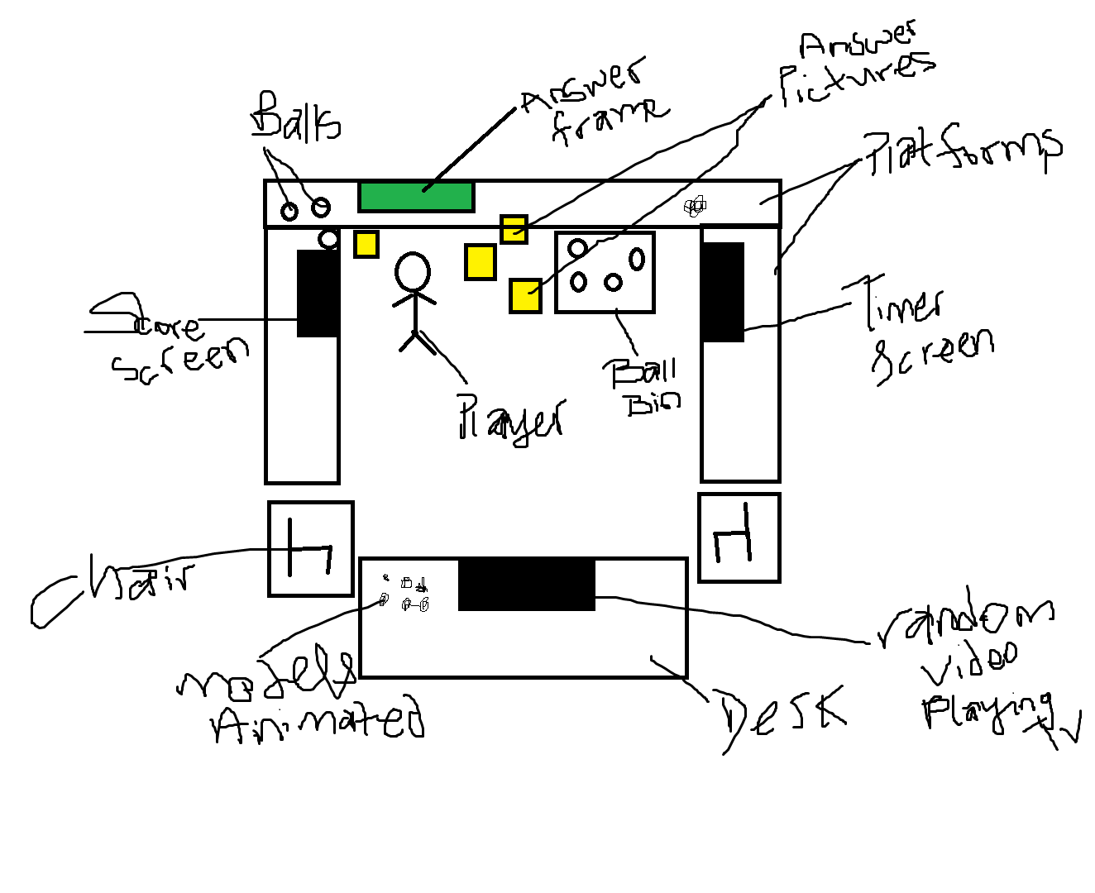

Diagram may not represent the final setup but contains just a basic information of what some of the core mechanisms could contain.